Year 12 Essentials
Statistics and Data Collection Revision Quiz

1. How is a census different from a sample?

2. Describe three different methods of sampling data

3. Sarah wants to find out where people shop. She takes a sample of people from her local supermarket and asks them where they shop.
Explain why this is a biased sample.

4. Classify the following scatter plots by their direction, form and strength.

Graph | Dir. | Form | Str. | Graph | Dir. | Form | Str. | Graph | Dir. | Form | Str.
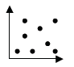 |  |  |  | 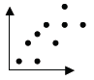 |  |  |  | 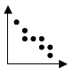
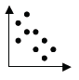 |  |  |  | 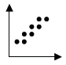 |  |  |  | 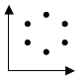

5. Which of the following scatter plots most closely approximates a line of best fit for the data shown?

Graph A | Graph B | Graph C | Graph D
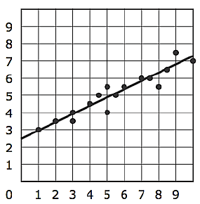 | 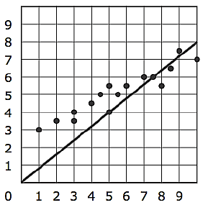 | 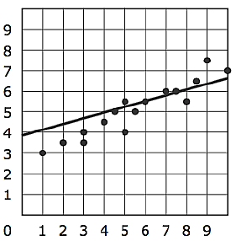 | 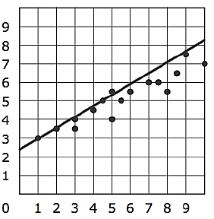

6. Dave asked his friends how many Likes their Instagram posts generate in a day. He collected the following data.
Number of Instagram Posts | 10 | 10 | 15 | 20 | 25 | 25 | 30 | 40
Number of Likes | 2 | 4 | 8 | 12 | 14 | 20 | 20 | 32
- Create a scatterplot of this data.

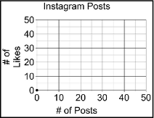

- Describe the association (Direction, Form and Strength) between the variables.

- Draw a trend line through your data.

- Use your trend line to predict the number of likes for 50 posts.

- Dave received 25 likes. Using your trend line, predict how many posts he made?

- Comment on the reliability of your predictions.

- Explain how the data collected in this survey could have contained biases.

